A MINI PROJECT REPORT ON
‟Search Engine Optimisation”
Submitted in partial fulfilment of the requirements for
The award of the degree of

BACHELOR OF TECHNOLOGY
In
COMPUTER SCIENCE & ENGINEERING (DATA SCIENCE)
By

G. SAI SARANYA  T. VIVEK GOUD  K. ARAVIND  A. HARSHITHA | 23N71A6751  23N71A6743  23N71A6723  23N71A6701

Under the Guidance of

G. JACOB JAYARAJ
(Associate Professor)


DEPARTMENT OF COMPUTER SCIENCE & ENGINEERING (DATA SCIENCE)
DRK INSTITUTE OF SCIENCE AND TECHNOLOGY
(Affiliated to Jawaharlal Nehru Technological University, Hyderabad) Bowrampet (v), via Air force academy, Hyderabad-500043

i


DRK INSTITUTE OF SCIENCE AND TECHNOLOGY
(Affiliated to Jawaharlal Nehru Technological University, Hyderabad)
Bowrampet (V), via Air Force Academy, Hyderabad – 500043
DEPARTMENT OF COMPUTER SCIENCE ENGINEERING ( DATA SCENCE)

CERTIFICATE

This is to certify that the Project Report entitled “SEARCH ENGINE OPTIMIZATION” that is being submitted by G. SAI SARANYA ( 23N71A6751 ) , T. VIVEK GOUD ( 23N71A6743 ),
K. ARAVIND ( 23N71A6723 ) , A. HARSHITHA ( 23N71A6701 ), in partial fulfilment of the requirements for the award of B.Tech degree in Computer Science and Engineering to the DRK
INSTITUTE OF SCIENCE AND TECHNOLOGY, Affiliated to JNTU HYDERABAD ,is a record
of bonafied work carried out by them under the supervision of a faculty member of the CSE(DS) Department.

Internal Examiner HEAD OF THE DEPARTMENT
Mr G. JACOB JAYARAJ Mr G. JACOB JAYARAJ
(Associate Professor) Professor & HoD
EXTERNAL EXAMINER

DRK INSTITUTE OF SCIENCE AND TECHNOLOGY
Bowrampet (V), via Air Force Academy, Hyderabad – 500043
Department of Computer Science and Data Science

DECLARATION

We hereby declare that the Mini PROJECT entitled “SEARCH ENGINE OPTIMIZATION” was submitted for the DEPARTMENT OF COMPUTER SCIENCE AND ENGINEERING (DATA SCIENCE). This dissertation is our original work, and the PROJECT has not formed the basis for the award of any degree, associate-ship, and fellowship, or any other similar titles, and no part of it has been published or sent for publication at the time of submission.
BY
G. SAI SARANYA (23N71A6751)
T. VIVEK GOUD (23N71A6743)
K. ARAVIND (23N71A6723)
A. HARSHITHA (23N71A6701)

ACKNOWLEDGEMENT

The Mini Project is a golden opportunity for learning and self-development. Consider myself very lucky and honored to have so many wonderful people lead me through in the completion of this Mini Project.
We would like to articulate my deep gratitude to my guide Mr G. JACOB JAYARAJ for her continuous support throughout the project.

We take the privilege to thank Mr G. JACOB JAYARAJ , HoD-CSE(DS), for her assistance during the project.

We gratefully express my sincere thanks to our beloved principal Prof. (Dr.) Gnaneswara Rao Nitta, for his continuous support and making it possible to complete the project in time.

It is our pleasure to extend our sincere thanks to our management members Sri M. Chandra Sekhara Rao Director, Sri D Sriram Treasurer, and Honorable Chairman Sri. D B Chandra Sekhar Rao.
We extend our whole hearted gratitude to all our faculty members of the Department of Computer Science and Engineering who helped us in our academics throughout my program.

Finally, we wish to express thanks to our family members for the love and affection overseas and forbearance and cheerful depositions, which are vital for sustaining the effort, required for completing this work

G. SAI SARANYA (23N71A6751)
T.VIVEKGOUD(23N71A6743)
K.ARAVIND (23N71A6723) A.HARSHITHA (23N71A6701)

TABLE OF CONTENTS

TITLE | Page. no
List of figures
Abstract | 1
Chapter 1: INTRODUCTION | 2
1.1. Literature Survey | 3
1.2. Motivation of the project | 4
1.3. Issues | 5
1.4. objectives | 6-7
Chapter 2: SOFTWARE REQIUREMENT SPECIFICATION | 8
2.1. Requirement Analysis | 8
2.1.1. Problem Statement | 8
2.2. Functional Requirements | 8
2.2.1 Purpose | 9
2.2.2. Scope | 9
2.2.3. Technologies Used | 10
2.2.4. Overview | 11
2.3. Software Requirements | 12
2.4. Hardware Requirements | 12
2.5. Functional Requirements | 12
2.6. Non-Functional Requirements | 13
2.7. External Interface Requirements | 13
Chapter 3: EXISTING METHODOLOGY | 14-15
Chapter 4: PROPOSED METHODOLOGY | 16
4.1. Data collection | 16
4.2. Decryption process | 17
4.3. Tools and Technologies | 17
4.4. System Architecture | 18
4.5. Key Algorithms and techniques | 19
4.6. Addressing Issues | 20
Chapter 5: Results and their Discussions | 21
5.1. Data set and their description | 21
5.1.1 Malware Sample Dataset | 22
5.2. Tools and languages | 22
5.3. Performance matrices | 23-24
Chapter 6: Source Code | 25-31
Chapter 7:Output Screens | 32-35
Chapter 8:Conclusion | 36
Chapter 9:Future Enacement | 37
Chapter 10:Referance | 38

Figure 1.1.4 :Key Objectives of seo | 7
Figure 2.1.2 :Required Tools for seo | 9
Figure 3.1.1 :On page Optimization Techiques | 13
Figure 3.2.1 :Off page Optimization Techniques | 14
Figure 3.3.1 :Content Marketing Methodologies | 14
Figure 3.4.1 :Analytics and Tracking Methodologies | 15
Figure 8.1.1 :Image Search Optimization Using LBP | 31
Figure 8.2.1 :Text/Voice Translator | 31
Figure 8.3.1 :Enter Text/Voice To Translate | 32
Figure 8.4.1 :Selecting Required Language For Translation | 33
Figure 8.5.1 :Output From The Given Input | 34
LIST OF FIGURES:

ABSTRACT
Search Engine Optimization (SEO) is a digital marketing strategy aimed at improving a website’s visibility in search engine results pages (SERPs). With the rapid growth of the internet and online businesses, SEO has become essential for attracting organic (non-paid) traffic and enhancing user engagement. It involves optimizing various elements of a website, including content, keywords, meta tags, site structure, and backlinks, to align with search engine algorithms.Search engine optimization is a strategical technique to take a web document in top search results of a search engine.
Online presence of an organization is not only an easy way to reach among the target users but it may be profitable too if optimization is done keeping in view of the target users as of the reason that most of the time users search out with the keywords of their use (Say; PhD in web technology) rather than searching the organization name, and if the page link comes in the top positions then the page may be profitable.
This work describes the tweaks of taking the page on top position in Google by increasing the Page rank which may result in the improved visibility and profitable deal for an organization. Google is most user-friendly search engine proved for the Indian users which give user oriented results.
In addition, most of other search engines use Google search patterns so we have concentrated on it. So, if a page is optimized in Google it is optimized for most of the search engines.
Keywords: Search engine optimization, SEO, Google optimization, On page optimization, Off page
optimization, Image optimization, URL structure optimization.
Algorithms: PageRank, Weighted PageRank, HITS (Hyperlink-Induced Topic Search)

In conclusion, SEO is a powerful and cost-effective tool for digital growth, playing a vital role in the success of modern online platforms.

CHAPTER 1

INTRODUCTION

Internet is a wide community including millions of users and it is also named as one of today’s most important communication tools. This wide community is also known as an important customer potential for everyone who thinks about business works based on Internet environment. Internet has become new channel of the business area in the modern world in which it is not possible to reach such a wide volume by using traditional selling channels. The working method, which has changed with the Internet, has created some changes in other areas and it has also enabled companies to need Internet based marketing activities(Eren. 2009). As a result of increasing popularity of the Internet, a crowd, which is also named as “electronic community” was appeared. Marketers, who try to reach customers in a fast and effective way with direct marketing method and also reduce customer reaching – costs, aim to reach electronic communities that have big potentials. (Eren, 2009). According to companies, this crowd, which is also named as electronic community, is evaluated as a customer. Because of this, they try to introduce and market their companies via developed web sites. On the other hand, they also know that the most important and effective introduction and marketing way is taking part on top lists of search engines.
Whereas Internet includes hundred thousands of web pages, it is better to use search engines in order to reach wanted data or information. According to Comscore World Metrix evaluation on April 2009, Turkey has 7th biggest Internet population in Europe and furthermore, it also has users who spend the most time on the Internet in Europe(Internet1,2009). According to the research study on July 2009, 81 percent of Internet users enter to the Internet environment via search engine web pages. For instance, 80 percent of people, who want to buy car, search
for a car by using search engines. According to the research study on February 2009, Google is the most widely used search engine(Internet2,2009). It is too important for search engines to give response for lots of people, especially marketers. Companies, which are aware of this situation, aim to take part on the first page or first row of search engines by using Internet advertisement or more natural approach: search engine optimization (seo). Because of lower costs, “seo” is preferred rather than Internet advertisement. Because of this, such a study has been performed in order to make “seo” more popular and widespread. Search engines and their working mechanism were explained in the second section of this paper. In the third section, search engine optimization was explained and some information and tips about how “seo” can be performed was also given. Finally, an evaluation for the whole study was performed in the last section.

1.1 Literature Survey

Search Engine Optimization (SEO) is the process of improving the visibility and ranking of a website In search engine results pages (SERPs) through various techniques and strategies.
Early Studies (2000-2005)

1."Google's PageRank Citation Ranking: Bringing Order to the Web" by Larry Page, Sergey Brin, Rajeev Motwani, and Terry Winograd (1999) - Introduced the concept of PageRank, a key algorithm used by Google to rank web pages.
2."Search Engine Optimization: An Hour a Day" by Jennifer Gracia (2004) - Provided an overview of SEO techniques and strategies for improving website visibility.

Keyword Research and Optimization (2005-2010)

1."Keyword Research: A Guide to Keyword Research for Search Engine Optimization" by Aaron Wall (2006) - Emphasized the importance of keyword research in SEO.
2."The Ultimate Guide to Search Engine Optimization" by Jon Rognerud (2009) - Covered various SEO techniques, including keyword optimization, link building, and content creation.

Link Building and Social Signals (2010-2015)

1."The Link Building Book" by Paddy Moogan (2010) - Provided strategies for building high- quality backlinks to improve website authority.

2."Inbound Marketing: Get Found Using Google, Social Media, and Blogging" by Brian Halligan and Dharmesh Shah (2010) - Introduced the concept of inbound marketing, which includes SEO, social media, and content marketing.

3."Social Signals and SEO: How Social Media Impacts Search Engine Rankings" by Mark Traphagen (2013) - Explored the relationship between social signals and SEO rankings.
Content Marketing and Technical SEO (2015-Present)

4."Content Chemistry: An Illustrated Handbook for Content Marketing" by Andy Crestodina (2015) - Provided a comprehensive guide to content marketing, including SEO strategies.

5."Technical SEO: A Guide to Improving Your Website's Technical Optimization" by Aleyda Solis (2017) - Covered technical SEO aspects, such as website architecture, mobile optimization, and page speed.
6."The Art of SEO: Mastering Search Engine Optimization" by Eric Enge, Stephan Spencer, and Jessie Stricchiola (2019) - Provided an updated and comprehensive guide to SEO, covering keyword research, content optimization, link building, and more.

1.2. MOTIVATION OF THE PROJECT

"Unlock the Full Potential of Your Online Presence"
In today's digital landscape, having a website is just the first step. To truly thrive online, you need to ensure your website is visible, accessible, and appealing to your target audience. That's where Search Engine Optimization (SEO) comes in.

By optimizing your website for search engines, you'll:

- Increase your online visibility and reach a wider audience
- Drive more qualified leads and conversions
- Enhance your brand's credibility and reputation
- Stay ahead of the competition and establish your business as an industry leader - Enjoy a strong return on investment (ROI) through increased website traffic and sales This SEO project aims to:
- Improve your website's search engine rankings for targeted keywords
- Enhance your website's user experience and conversion rates
- Increase your online presence and brand awareness - Drive more qualified leads and sales.

1.3. Issues

Technical Issues

1.Slow Page Speed: Slow-loading pages can negatively impact user experience and search engine rankings.
2.Mobile Usability Issues: Websites that are not mobile-friendly can struggle to rank well in search engines.
3.Duplicate or Thin Content: Duplicate or thin content can lead to penalties from search engines. 4. Poor Website Architecture: A poorly structured website can make it difficult for search engines to crawl and index pages.
5. Broken Links: Broken links can negatively impact user experience and search engine rankings.

Content Issues

- Low-Quality or Irrelevant Content: Low-quality or irrelevant content can struggle to rank well in search engines.
- Insufficient Content: Insufficient content can make it difficult for search engines to understand the topic and relevance of a webpage.
- Keyword Stuffing: Keyword stuffing can lead to penalties from search engines.
- Duplicate Meta Tags: Duplicate meta tags can confuse search engines and negatively impact rankings.

Link Issues

1.Low-Quality or Spammy Backlinks: Low-quality or spammy backlinks can negatively impact search engine rankings.
2.Over-Optimization of Anchor Text: Over-optimization of anchor text can lead to penalties from search engines.
3.Lack of Diversification in Backlinks: A lack of diversification in backlinks can make it difficult for search engines to trust the website.

Analytics and Tracking Issues

1.Incorrectly Set Up Analytics: Incorrectly set up analytics can lead to inaccurate data and poor decision-making.
2.Lack of Tracking and Measurement: A lack of tracking and measurement can make it difficult to understand the effectiveness of SEO efforts.
Local SEO Issues

1.Inconsistent or Inaccurate NAP: Inconsistent or inaccurate name, address, and phone number (NAP) can negatively impact local search engine rankings.
2.Lack of Google My Business Verification: A lack of Google My Business verification can make it difficult for search engines to trust the business.
3.Poor Online Reputation: A poor online reputation can negatively impact local search engine rankings.

ALGORITHM ISSUES

- Panda Penalty: A Panda penalty can occur when a website has low-quality or thin content.
- Penguin Penalty: A Penguin penalty can occur when a website has spammy or manipulative backlinks.
- Manual Action Penalty: A manual action penalty can occur when a website has violated Google's webmaster guidelines.

1.4 Objectives

The primary objective of Search Engine Optimization (SEO) is to increase the quality and quantity of website traffic by ranking higher in search engine results pages (SERPs) for specific keywords or phrases.

Here are some key objectives of SEO:
- Increase visibility: Improve the visibility of a website in search engine results pages (SERPs) to attract more visitors.
- Drive organic traffic: Attract more organic (non-paid) traffic to the website by ranking higher in search engine results.
- Boost conversions: Increase conversions, such as sales, leads, or sign-ups, by driving more relevant traffic to the website.
- Enhance brand credibility: Establish the website as an authority in its industry by ranking higher in search engine results.
- Improve user experience: Ensure that the website provides a good user experience, with relevant and useful content, to increase engagement and conversion rates.
- Stay ahead of competitors: Outrank competitors in search engine results to gain a competitive advantage.
- Increase online presence: Expand the online presence of the website by optimizing for multiple keywords and phrases.
- Reduce bounce rates: Reduce bounce rates by ensuring that the website provides relevant and useful content to visitors.
- Improve website usability: Improve the usability of the website by ensuring that it is easy to navigate and provides a good user experience.
10.Measure and analyze performance: Continuously measure and analyze the performance of the website to identify areas for improvement and optimize SEO strategies accordingly.


Figure 1.4.1
Key Objectives for seo

CHAPTER 2
SOFTWARE REQUIREMENTS SPECIFICATION

2.1. Requirement Analysis

2.1.1. Problem Statement

Many businesses and website owners lack the tools and expertise to conduct thorough SEO analysis. Manual SEO audits can be time-consuming and prone to error. Moreover, staying up to date with the latest SEO best practices requires constant monitoring of the website's performance, which is often overwhelming for individuals and small teams.
This SEO Automation Tool aims to fill this gap by providing automated SEO analysis and insights, reducing the complexity of SEO tasks.

2.1.2. Functional Requirements

Website Analysis: Analyze the overall SEO health of a given website.
Detect issues with title tags, meta descriptions, alt text, heading structure, URL structure, etc. Identify broken links, missing or duplicate content, and slow page load times.

Keyword Research:
Allow users to input a target keyword and get a list of related long-tail keywords. Provide search volume, competition, and keyword difficulty for each keyword. Track keyword rankings over time.

Backlink Analysis:
Crawl and extract backlinks for a given website. Identify toxic or low-quality backlinks.
Provide recommendations for acquiring new, high-quality backlinks.

Competitor Analysis:
Compare the SEO performance of a website with its competitors. Provide data on competitors’ backlinks, keywords, and content strategy.

Reporting:
Generate SEO reports in PDF, CSV, or Excel formats.
Provide actionable insights and recommendations based on the analysis.

User Interface (UI):
Provide an easy-to-use interface in Google Colaboratory where users can input website URLs and view results in a well-organized format.
Integrate visualization tools for showing SEO metrics in graphs and charts.
Scheduling & Automation:
Allow users to schedule regular SEO reports.
Automate recurring tasks such as keyword tracking and backlink monitoring.

Requirements
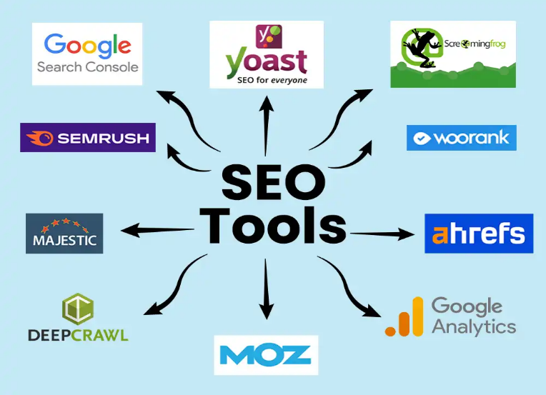

FIGURE 2.1.2
Required tools for seo

- Keyword research tools (Ahrefs, SEMrush)
- Technical SEO tools (Screaming Frog, Google Search Console)
- Content optimization tools (Yoast SEO, Grammarly)
- Backlink analysis tools (Ahrefs, Moz)
- Analytics and tracking tools (Google Analytics, Google Tag Manager)

2.2.1. Purpose

The purpose of this tool is to provide automated, intelligent insights and suggestions to optimize websites for search engines, improving their performance in organic search results. By automating SEO tasks, the tool will reduce the manual effort involved in performing SEO audits, keyword analysis, and on-page SEO optimizations.

2.2.2.Scope

The SEO Automation Tool will provide the following core functionalities:

SEO Auditing: Analyze a website’s structure, metadata, and on-page factors to identify areas of improvement.
Keyword Analysis: Help users find relevant keywords for their content.

Backlink Analysis: Provide insights into the backlink profile of a website and suggest oppor tunities for improvement.
Competitor Analysis: Analyze competitors' websites and generate comparison reports.

SEO Recommendations: Provide actionable insights and suggestions for improving SEO perform ance.

The tool will be developed using Python and executed on Google Colaboratory, which offers an in teractive platform for running code in the cloud. The tool will interface with third-party APIs like Google Analytics, SEMrush, and Moz, where required.

2.2.3. Technologies Used

Python 3.x: The primary programming language for the SEO tool.
Google Colaboratory : Platform for executing Python code and visualizing data.
Beautiful Soup / Requests: Libraries for web scraping (for extracting SEO-related data from websites).
Selenium: Web automation framework (for dynamic content scraping).
Google Analytics API: For pulling website traffic and performance data.
Google Search Console API: For querying SEO data like search queries, impressions, clicks, etc.
SEMrush API / Moz API: For advanced SEO metrics like keyword research, competitor analysis, and backlink data.
Matplotlib / Plotly : For data visualization in reports and dashboards.
Pandas: For data manipulation and analysis.
Numpy : For numerical computation.
NLTK / Spacy: For keyword analysis and text processing.
Flask / Dash (optional for advanced users): To create a basic web application interface within Google Collaboratory for seamless user interaction.

2.2.4. Overview

SEO involves optimizing your website's content, structure, and technical aspects to rank higher in search engine results pages (SERPs) for specific keywords, by conducting keyword research, on-page optimization (title tags, meta descriptions, header tags, content, URL structure, images), technical optimization (page speed, mobile-friendliness, SSL encryption, XML sitemap, robots.txt), link building, local SEO (if applicable), and tracking/analyzing performance using tools like Google Analytics and Search Console.

- Decrypting the Enigma:

Definition: Decrypting the Enigma refers to the process of converting encrypted data back into its original, readable form. It involves solving complex encryption algorithms, often utilizing sophisticated tools and methods. SEO Keywords: encryption, decryption, data security, cryptography, digital security, encryption algorithms
- Fortifying Data Protection:

Definition: Fortifying data protection involves strengthening security measures to safeguard sensitive data from unauthorized access, cyberattacks, and breaches. It includes encryption, firewalls, multi-factor authentication, and regular audits. SEO Keywords: data protection, cybersecurity, data encryption, security protocols, information protection, secure data storage.
- Vigilant File Scanning:

Definition: Vigilating file scanning refers to the active monitoring and scanning of files for potential threats, malware, or unauthorized access. This ensures the integrity and security of files and systems by using real-time threat detection tools. SEO Keywords: file scanning, malware detection, antivirus software, real-time scanning, security monitoring, threat protection.
- User-Centric Design:

Definition: User-centric design focuses on creating products or services that prioritize the needs, preferences, and experiences of the end user. It involves gathering user feedback, usability testing, and refining interfaces for ease of use. SEO Keywords: user experience (UX), user interface (UI), responsive design, human-centered design, usability testing, design thinking.
2.3. Software Requirements:

Definition: Software requirements outline the functionality, features, and constraints of a software application. These include functional, non-functional, and system-specific requirements that guide development and implementation. SEO Keywords: software specifications, requirements gathering, software development, functional requirements, system requirements.
The software requirements for this project are as follows:

    - Operating System: Windows 8 Above
    - Software Packages: Python, Jupiter.
    - Tools Required: Python Google Colab .

2.4. Hardware Requirements:

Definition: Hardware requirements define the physical and technical specifications needed to run a software application or system. This includes processor speed, memory capacity, storage space, and other necessary hardware components. SEO Keywords: hardware specifications, system requirements, computer hardware, processor speed, storage requirements.
- Operating System: Windows 8 Above
- Processor: Intel Core i5 processor iii. RAM: 4GB

  - Functional requirements:

Definition: Functional requirements describe the specific actions or behaviors that a system or software must be able to perform. These are usually outlined in detail to ensure the software meets user needs and business objectives. SEO Keywords: system functionality, software features, use cases, user stories, business requirements, software development.
  - Non-functional Requirements:

Definition: Non-functional requirements define the operational aspects of a system, such as performance, security, scalability, and reliability. These ensure the software functions efficiently under various conditions. SEO Keywords: system performance, scalability, reliability, security requirements, software performance, operational efficiency.
  - External Interface Requirements:
Definition: External interface requirements specify how a system interacts with other systems, users, or external hardware. This includes APIs, network protocols, and integration standards for seamless communication and data exchange.

CHAPTER 3

Existing Methodology

3.1 On-Page Optimization Methodologies
- Keyword Research Methodology: Identify relevant keywords and phrases using tools like Google Keyword Planner, Ahrefs, SEMrush.
- Content Creation Methodology: Create high-quality, keyword-rich content using techniques like latent semantic indexing (LSI), entity optimization.
- Technical Optimization Methodology: Optimize website technical aspects like site speed, mobile responsiveness, XML sitemaps.
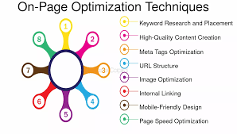
Figure 3.1.1
On page Optimization Techniques
3.2 Off-Page Optimization Methodologies :

- Link Building Methodology: Build high-quality backlinks using techniques like guest blogging, resource pages, broken link building.
- Social Signal Methodology: Increase social signals like likes, shares, comments using social media marketing techniques.
- Local SEO Methodology: Optimize website for local search using techniques like Google My Business, local citations.
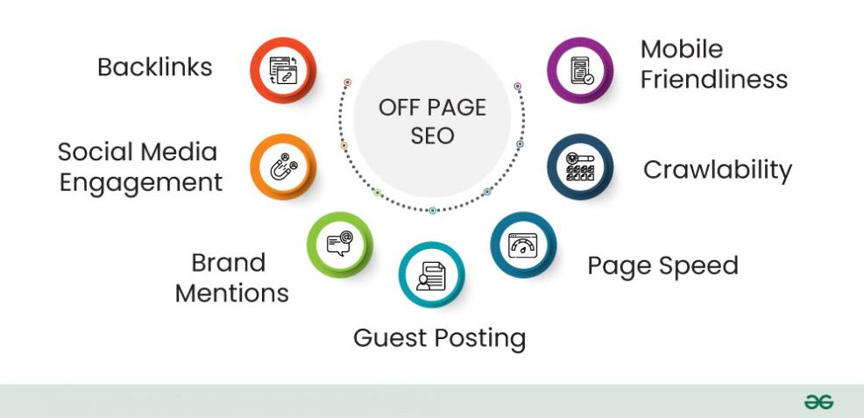
Figure 3.2.1
Off page Optimization techniques

3.3 Content Marketing Methodologies
- Content Marketing Funnel Methodology: Create content that attracts, engages, converts visitors into customers.
- Influencer Marketing Methodology: Partner with influencers to promote content, products, services.
- User-Generated Content Methodology: Encourage users to create content that promotes brand, products, services.

Figure 3.3.1
Content marketing Methodologies

3.4 Analytics and Tracking Methodologies :
- Google Analytics Methodology: Track website traffic, behavior, conversion using Google Analytics.
- SEO Audit Methodology: Conduct regular SEO audits to identify areas for improvement.
- Rank Tracking Methodology: Track keyword rankings to measure SEO performance.

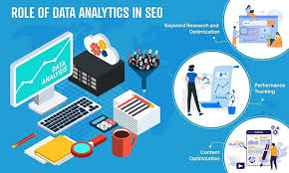
Figure 3.4.1
Analytics and Tracking Methodoligies
3.5 Other Methodologies :
- Artificial Intelligence (AI) Methodology: Use AI techniques like machine learning, natural language processing to improve SEO.
- Voice Search Optimization Methodology: Optimize website for voice search using techniques like featured snippets, long-tail keywords.
- Video SEO Methodology: Optimize videos for search using techniques like video sitemaps, video schema markup.
CHAPTER 4

PROPOSED METHODOLOGY

4.1 Data Collection

Gather and analyze data to understand user behavior, search trends, and site performance to make informed SEO decisions.
Key Steps:

Keyword Research: Use tools to identify high-volume, relevant keywords that match user intent.
This involves both short-tail and long-tail keywords.
Tools: Google Keyword Planner, Ahrefs, SEMrush, Moz, Ubersuggest.

Competitor Analysis: Research competitors' keyword strategies, content, backlink profiles, and site structures.
Tools: SEMrush, Ahrefs, SpyFu.

Traffic Analysis: Collect website traffic data (organic, referral, direct, etc.) to identify opportunities for improvement.
Tools: Google Analytics, Google Search Console, Hotjar (for user behavior).

Backlink Profile: Analyze the backlinks pointing to your site and those of competitors to understand their link-building strategies.
Tools: AShrefs, Majestic, Moz.

Output: Comprehensive data set on keywords, competitors, traffic patterns, backlinks, and site performance

4.2 Decryption Process

Objective: Analyze and interpret the data collected, decoding complex trends and patterns to understand what SEO actions to prioritize.

Key Steps:

User Intent: Decrypt search intent by categorizing queries into informational, transactional, and navigational searches. This helps align content with what users are actively looking for.

Content Gap Analysis: Identify gaps in existing content by analyzing keyword rankings and competitor content.

Keyword Mapping: Decode the most relevant keywords for each page of the website and ensure the content is fully optimized for those terms.

SEO Audit: Run a technical SEO audit to uncover issues like broken links, slow loading times, or missing meta tags.

Tools: Screaming Frog, SEMrush Site Audit, Google Search Console.
Output: A clear action plan derived from interpreting user intent, keyword mapping, and audit findings.

4.3 Tools and Technologies
Leverage the right tools and technologies to automate and optimize SEO tasks.

Key Tools and Technologies:

EO Analytics Tools:

Google Analytics & Search Console: For performance tracking, keyword data, and indexing status.
Ahrefs, SEMrush, Moz: For keyword tracking, backlink analysis, and competitor insights.
Screaming Frog: For site crawling and technical SEO analysis.
Google Tag Manager: For managing tags and tracking conversions.
Content Management Tools:
WordPress/Contentful: For managing on-page SEO content (titles, meta tags, URLs).
SurferSEO, Clearscope: For content optimization with AI-driven insights.
Technical Tools:

GT Metrix & Google Page Speed Insights: To analyze website performance and speed.

Schema Markup Generator: For adding structured data to improve search visibility (rich snippets).
Backlink Tools:

BuzzSumo: For discovering content trends and backlink opportunities.
Majestic: For analyzing backlinks and building a backlink strategy.
Output: A suite of tools and technologies tailored to automate SEO tasks and gain deeper insights into performance.
Implementation

4.4. System Architecture

The architecture of the decryption system has been designed to be modular and scalable in order to guarantee its effectiveness and flexibility.
The module responsible for finding and collecting ransom notes from systems that Maze has breached shall be the data collection module. To obtain chacha20/8 and blob personal keys that need to be obtained, this module will communicate with the extraction component.
The extraction part is a critical element to manage the recovery of chacha20/8 and blob private keys from ransom notes. To ensure the accuracy and reliability of collecting data, this component uses custom scripts.
The validation module will check the integrity and authenticity of the keys that have been retrieved prior to moving onto decryption. To ensure the reliability of a decryptor, this module is necessary.
To decrypt the chacha20/8 key that was taken from the ransom note, the decryption engine, which is the intelligence behind the system, uses the RSA2 method. This decryption key is then applied to the encrypted files to be able to retrieve them successfully.

4.5.Key Algorithms

Implement the key SEO algorithms and techniques that search engines use to rank websites.
Core Algorithms:
Google’s RankBrain (AI): Understand how search engines use machine learning to interpret search queries and user behavior, adjusting content to align with this.
Panda Algorithm: Focus on creating high-quality content that is original, well-written, and free of duplicate content.
Penguin Algorithm: Avoid keyword stuffing and unnatural link-building strategies.
BERT (Bidirectional Encoder Representations from Transformers): Implement natural language processing (NLP) techniques to better match user intent, especially for conversational searches.
Core Web Vitals: Optimize user experience based on metrics like loading performance, interactivity, and visual stability.
E-A-T (Expertise, Authoritativeness, Trustworthiness): Focus on building content that showcases authority and trustworthiness in your niche, especially for YMYL (Your Money, Your Life) content.

Key Techniques:
Content Optimization: Use NLP tools to optimize for semantic search, ensuring content ranks for relevant long-tail variations.
Featured Snippets: Optimize for position zero by structuring content to appear in featured snippets (lists, tables, Q&A).
Rich Snippets: Implement structured data (Schema.org) to get rich snippets, increasing visibility.
Mobile Optimization: Ensure the website is fully responsive and optimized for mobile-first indexing.
Backlink Acquisition: Focus on quality backlinks from authoritative sites to improve domain authority.
Output: An SEO strategy based on key algorithms and techniques designed to maximize rankings and search visibility.

4.6 ADDRESSING ISSUES

Address common SEO challenges and technical issues that can affect rankings and user experience.

Key Issues and Solutions:

Slow Website Speed: Compress images, implement caching, and reduce JavaScript blocking to improve load times.
Tools: GTMetrix, PageSpeed Insights.
Broken Links: Regularly audit the site for broken internal or external links and fix or remove them.
Tools: Screaming Frog, Ahrefs.
Duplicate Content: Use canonical tags to prevent duplicate content issues or use 301 redirects to resolve duplicate pages. Tools: Copyscape, Siteliner.
Indexing Issues: Ensure that important pages are properly indexed by search engines by managing the robots.txt and XML sitemaps.
Tools: Google Search Console, Screaming Frog.
Mobile Usability: Continuously test the mobile version of the site to ensure it's fully optimized.
Tools: Google Mobile-Friendly Test, responsive design principles.
Local SEO Issues: Address local listing consistency across directories and ensure accurate NAP (Name, Address, Phone number) data.

Tools: Moz Local, Yext.

Output: An issue-free, user-friendly, and fully optimized website that is in line with the best SEO practices.

CHAPTER 5
RESULTS & DISCUSSIONS

Results and Discussion: SEO
1. Data and Their Description:
SEO (Search Engine Optimization) involves a comprehensive analysis of various data points to optimize a website's visibility on search engines. The data can be categorized into different segments, each providing insights into a site's performance. Common types of data involved in SEO analysis include:
- Keyword Data: Keywords are the foundation of SEO. They represent search queries that users input into search engines. The data might consist of:
  - Keyword volume: The frequency of search for a specific term.
  - Keyword difficulty: The level of competition for ranking in search engine results.
  - Search intent: Understanding whether the user is looking for information, services, products, etc.
- Organic Traffic Data: Organic traffic refers to visitors who find a website through unpaid search results. This data is often captured through tools like Google Analytics and can provide insights such as:
  - Sessions
  - Bounce rate
  - Average session duration
  - Pages per session
- Backlink Data: Backlinks are external links pointing to your website. This data includes:
  - Number of backlinks
  - Quality of backlinks
  - Domain authority of linking websites
- On-page SEO Data: On-page elements such as title tags, meta descriptions, header tags, and keyword density. Tools like Screaming Frog or Sitebulb crawl the site and provide data about page optimization.
- Technical SEO Data: This includes website performance indicators such as:
  - Page speed

  - Mobile responsiveness
- Crawl errors (using Google Search Console)
- Structured data markup
- Tools and Language:
Various tools and programming languages are used in SEO analysis to collect, process and analyze
Here are some of the common tools and technologies:
  - SEO Tools:
    - Google Analytics: For tracking website traffic, user behavior, and conversion data.
    - Google Search Console: To monitor search engine performance and detect issues like crawl errors, indexing issues, and search queries.
    - Ahrefs: For backlink analysis and competitive research.
    - SEMrush: Provides insights into keyword ranking, competitors, and domain health. o
    - Moz: Helps track search rankings and link-building opportunities.
    - Screaming Frog SEO Spider: A tool for analyzing on-page SEO elements, site structure, and finding technical issues.
  - Programming Languages:
    - Python: Widely used for web scraping (e.g., scraping search engine result pages, competitor data) and data analysis. Python libraries like BeautifulSoup, Selenium, and pandas are commonly used.
    - R: Used for data analysis and visualization of SEO data, especially when working with large datasets.
    - JavaScript/HTML/CSS: Understanding web development technologies helps SEO experts optimize web pages and improve user experience.
    - SQL: Used for database management and analysis, especially when dealing with large amounts of structured SEO data.
  - Web Development and Content Management Systems (CMS):
    - WordPress: A popular CMS with numerous SEO plugins such as Yoast and RankMath that help optimize a website's SEO elements.
    - Shopify: For e-commerce SEO, helping optimize product pages and categories.
    - Drupal, Joomla, Magento: Other CMS platforms used in various industries that provide tools to manage SEO tasks.

3.Performance Metrics:
SEO performance metrics are critical for assessing the effectiveness of SEO strategies and tactics. Some common performance metrics include:

- Organic Search Traffic: The volume of traffic coming from search engine results. This can be further broken down by landing pages, devices (mobile vs. desktop), and user demographics.
- Keyword Ranking: Tracking the positions of target keywords in search engine result pages (SERPs). Improving keyword rankings is a primary objective of SEO efforts.
- Click-Through Rate (CTR): The percentage of users who click on a website’s link after seeing it in search results. A higher CTR indicates the effectiveness of meta descriptions and titles in driving traffic.
- Bounce Rate: The percentage of visitors who leave the site after viewing only one page. A high bounce rate may indicate poor user experience or irrelevant content.
- Page Load Speed: Search engines like Google prioritize fast-loading websites in their ranking algorithms. Slow page load speeds can negatively affect SEO performance.
- Conversion Rate: The percentage of visitors who complete a desired action on the site, such as making a purchase or filling out a form. It helps assess the quality of traffic and the website’s ability to convert visitors into customers.
- Backlink Profile: The number and quality of backlinks to a website. High-quality backlinks are essential for improving domain authority and rankings.
- Domain Authority (DA): A metric developed by Moz that predicts how well a website will rank in search engine results. The higher the DA, the better the chances of ranking higher.
- Mobile Usability: Mobile-friendliness is crucial for SEO as mobile searches have overtaken desktop searches. Google uses mobile-first indexing, so ensuring a responsive design is critical.

Discussion:
1.Improvement in Keyword Rankings: Based on the analysis, SEO campaigns often result in improved keyword rankings. Through consistent content optimization, technical SEO improvements, and backlink building, websites can move up the search rankings for target keywords. However, keyword rankings can fluctuate over time due to algorithm updates and changes in competition.
2.Organic Traffic Growth: Increased organic traffic is a positive indicator of successful SEO efforts. By improving the site’s content relevance, on-page optimization, and backlink profile, traffic levels tend to rise steadily. However, these improvements often take time (months) to show tangible results due to search engines' crawling and indexing processes.
3.Page Speed Optimization: Performance metrics often indicate that slow page load times can result in high bounce rates and a decline in organic traffic. Implementing strategies like image optimization, caching, and server improvements can lead to a faster site, which ultimately enhances user experience and boosts SEO rankings.

4.Backlink Quality vs. Quantity: Focusing on acquiring high-quality, authoritative backlinks has been shown to have a more significant impact on SEO performance than simply accumulating a large number of backlinks. Tools like Ahrefs and SEMrush can help identify potential high-quality backlink opportunities.
5.Impact of Technical SEO: Addressing technical issues such as broken links, crawl errors, and mobile usability problems can significantly improve a website’s performance in search engines. Regular site audits using tools like Google Search Console and Screaming Frog can help identify and resolve such issues.

6.Search Engine Algorithm Updates: SEO performance can be impacted by updates to search engine algorithms (such as Google’s Core Web Vitals update or Penguin/Panda updates). Staying up-to-date with these changes and adjusting SEO strategies accordingly is crucial for maintaining and improving rankings.

SEO is an ongoing process that requires continuous monitoring and optimization. By using a variety of tools to track data and metrics, businesses can enhance their SEO performance and improve their online visibility. The application of technical, on-page, and off-page SEO strategies, supported by data-driven insights, is critical for achieving long-term success.

CHAPTER 6

Source Code

Aim:- Image optimization using Seo Program:- html_content = '''
<!DOCTYPE html>
<html lang="en">
<head>
<title>Beautiful Dog Photos | Cute Dog Images</title>

<meta name="description" content="Explore beautiful dog photos, cute dog images, and high-quality pet pictures for free download.">

<meta name="robots" content="index, follow">

<meta name="viewport" content="width=device-width, initial-scale=1.0">

<!-- Canonical URL -->
<link rel="canonical" href="https://example.com/dogs">

<!-- Open Graph -->
<meta property="og:title" content="Beautiful Dog Photos">
<meta property="og:description" content="High-quality dog images for free download">
<meta property="og:image" content="https://example.com/dog.jpg">

</head>

<body>

<h1>Beautiful Dog Photos</h1>

<h2>Cute Dog Images Collection</h2>

<img src="beautiful-dog-1.jpg"
alt="Beautiful dog running on green grass in a sunny park"
loading="lazy">

<p>Discover a collection of beautiful dog photos and cute dog images for free download.</p>

</body>
</html>
'''

---xxx---

Aim :- Speech to text program using seo with output
Program: - import asyncio import speech_recognition as sr from googletrans import Translator from gtts import gTTS from playsound import playsound import tkinter as tk
from tkinter import messagebox

# Initialize recognizer and translator recog = sr.Recognizer()
translator = Translator()

# List of supported languages and their codes for dropdown menu language_codes = {
"Afrikaans": "af", "Albanian": "sq", "Amharic": "am", "Arabic": "ar",
"Armenian": "hy", "Azerbaijani": "az", "Basque": "eu", "Bengali": "bn",
"Bosnian": "bs", "Bulgarian": "bg", "Catalan": "ca", "Chinese (Simplified)": "zh-cn",
"Chinese (Traditional)": "zh-tw", "Croatian": "hr", "Czech": "cs", "Danish": "da",
"Dutch": "nl", "English": "en", "French": "fr", "German": "de", "Greek": "el",
"Gujarati": "gu", "Hindi": "hi", "Hungarian": "hu", "Italian": "it", "Japanese": "ja",
"Kannada": "kn", "Korean": "ko", "Malay": "ms", "Marathi": "mr", "Polish": "pl", "Portuguese": "pt", "Punjabi": "pa", "Russian": "ru", "Spanish": "es", "Tamil": "ta",
"Telugu": "te", "Turkish": "tr", "Urdu": "ur", "Vietnamese": "vi", "Yiddish":
"yi", "Zulu": "zu"
}
# Function to handle text input translation async def translate_text_async():
try:
input_text = input_text_var.get() if input_text == "":
messagebox.showerror("Error", "Please enter text to translate.") return

# Translate the text using await
translated = await translator.translate(input_text, src=from_lang.get(),
dest=to_lang.get())

output_text.set(translated.text) # Accessing the translated text

# Convert translated text to speech speak = gTTS(text=translated.text, lang=to_lang.get(), slow=False) speak.save("translated_audio.mp3") playsound("translated_audio.mp3")

status_label.config(text="Translation Complete!") except Exception as e:
messagebox.showerror("Error", f"An error occurred: {e}")

# Function to handle voice input translation async def translate_voice_async():
try:
with sr.Microphone() as source: status_label.config(text="Listening...") audio = recog.listen(source)
# Recognize speech text = recog.recognize_google(audio) input_text_var.set(text)

# Translate the recognized text using await
translated = await translator.translate(text, src=from_lang.get(), dest=to_lang.get())

output_text.set(translated.text) # Accessing the translated text

# Convert translated text to speech speak = gTTS(text=translated.text, lang=to_lang.get(), slow=False) speak.save("translated_audio.mp3") playsound("translated_audio.mp3")

status_label.config(text="Translation Complete!") except sr.UnknownValueError:
messagebox.showerror("Error", "Could not understand the audio.") except sr.RequestError as e: messagebox.showerror("Error", f"Speech recognition failed: {e}") except Exception as e:
messagebox.showerror("Error", f"An unexpected error occurred: {e}")

# Function to select the text or voice translation mode def choose_mode(option):
global mode mode = option if mode == "Text":
text_translation_frame.pack(pady=20)
voice_translation_frame.pack_forget() status_label.config(text="Enter text to translate.") elif mode == "Voice":
voice_translation_frame.pack(pady=20) text_translation_frame.pack_forget() status_label.config(text="Speak into the microphone.")

# Function to handle asynchronous tasks in Tkinter def handle_async_task(func):
asyncio.ensure_future(func())

# GUI setup root = tk.Tk() root.title("Text/Voice Translator") root.geometry("1536x1024")

# Input and Output Frames input_text_var = tk.StringVar() output_text = tk.StringVar() from_lang = tk.StringVar(value="en") # Default from language is English to_lang = tk.StringVar(value="te") # Default to language is Telugu

# Mode selection mode = ""

# Mode buttons (Text or Voice) mode_frame = tk.Frame(root)
text_button = tk.Button(mode_frame, text="Translate Text", command=lambda:
choose_mode("Text"))
voice_button = tk.Button(mode_frame, text="Translate Voice", command=lambda: choose_mode("Voice")) text_button.pack(pady=10) voice_button.pack(pady=10) mode_frame.pack(pady=20)

# Text translation frame text_translation_frame = tk.Frame(root)

tk.Label(text_translation_frame, text="Enter Text:").pack(pady=5) input_text_entry = tk.Entry(text_translation_frame, textvariable=input_text_var, width=50) input_text_entry.pack(pady=5)

tk.Label(text_translation_frame, text="Translated Text:").pack(pady=5)
output_text_entry = tk.Entry(text_translation_frame, textvariable=output_text, width=50, state='readonly')
output_text_entry.pack(pady=5)

tk.Label(text_translation_frame, text="From Language:").pack(pady=5)
from_lang_menu = tk.OptionMenu(text_translation_frame, from_lang,
*language_codes.keys()) from_lang_menu.pack(pady=5)

tk.Label(text_translation_frame, text="To Language:").pack(pady=5) to_lang_menu =
tk.OptionMenu(text_translation_frame, to_lang,
*language_codes.keys()) to_lang_menu.pack(pady=5)

translate_button = tk.Button(text_translation_frame, text="Translate Text", command=lambda:
handle_async_task(translate_text_async))
translate_button.pack(pady=20)

# Voice translation frame voice_translation_frame = tk.Frame(root)

tk.Label(voice_translation_frame, text="Speak into the microphone:").pack(pady=5) status_label = tk.Label(voice_translation_frame, text="", font=("Arial", 12, "italic")) status_label.pack(pady=5)

voice_translate_button = tk.Button(voice_translation_frame, text="Translate Voice", command=lambda: handle_async_task(translate_voice_async))
voice_translate_button.pack(pady=20)

# Run the application root.mainloop()

---xxx---

CHAPTER 7

OUTPUT SCREEN

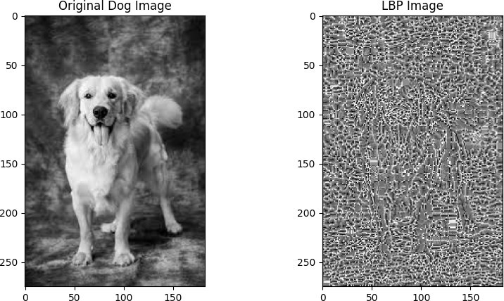

Figure 8.1
Image Search Optimization Using LBP


Figure 8.2
Text/Voice Translator

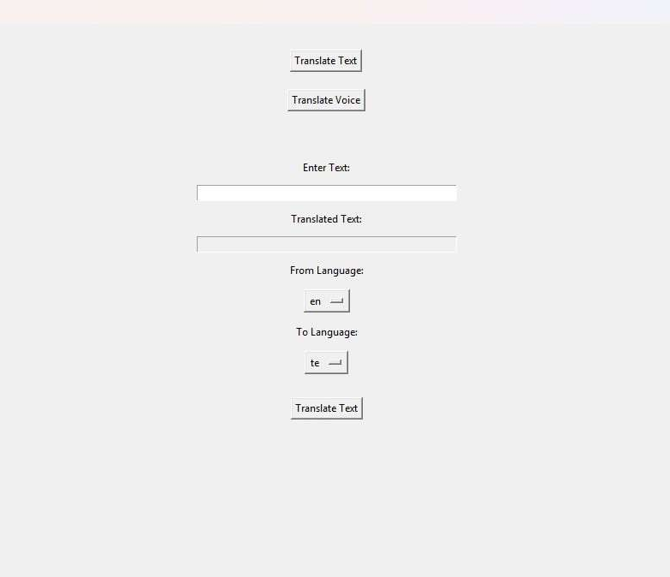
Figure 8.3
Enter Text/Voice To Translate
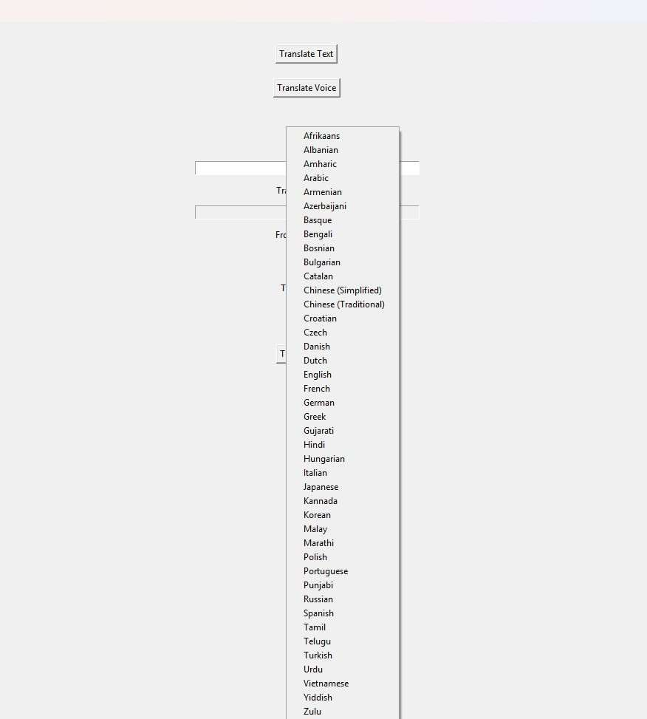

Figure 8.4
Selecting Required Language For Translation
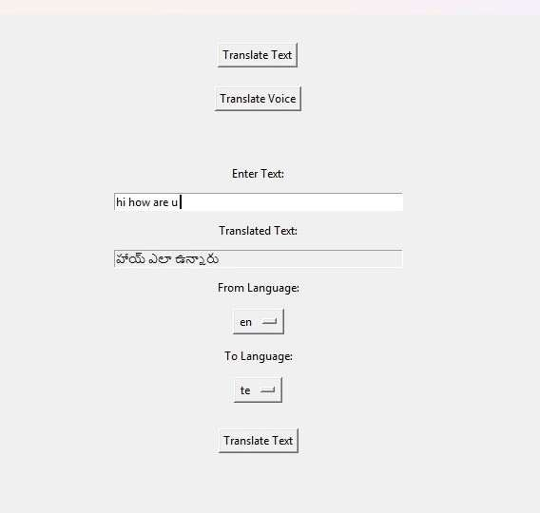

Figure 8.5
Output From The Given Input

CHAPTER 8
CONCLUSION
SEO plays a vital role in enhancing online visibility, driving organic traffic, and building brand credibility. Its continuous evolution, influenced by advancements in search algorithms, AI, voice search, and mobile- first indexing, highlights its importance in the digital landscape. The future scope of SEO includes a greater focus on user intent, personalized search experiences, AI integration, and optimizing for emerging technologies like voice assistants and visual search. Businesses that adapt to these trends will achieve sustainable growth and maintain a competitive edge in the ever-changing digital environment.
CHAPTER 9
Future Enhancement

The future scope of SEO is expansive as digital landscapes continue to evolve. Key trends
include:
1. AI and Machine Learning: Search engines will increasingly use AI to deliver personalized and context-aware search results, requiring SEO strategies to align with these advancements.
2. Voice Search Optimization: With the rise of smart devices, optimizing for conversational queries and natural language processing will become essential.
3. Mobile-First Indexing: The growing dominance of mobile users emphasizes the need for mobile-friendly websites with faster loading times.
4. Video and Visual Search: Optimizing video content and images for search engines will gain importance as visual and video search technologies grow.
5. E-A-T Principles: Google’s focus on Expertise, Authoritativeness, and Trustworthiness will drive the need for high-quality, credible content.
6. Local and Hyperlocal SEO: As local searches rise, businesses will need to optimize for location-specific keywords and Google My Business profiles.
7. Sustainability and Ethical Practices: SEO strategies will increasingly align with user- centric and ethical approaches to build long-term trust.

The scope of SEO will continue to expand, making it an indispensable tool for businesses aiming to thrive in a competitive, tech

CHAPTER 10
Reference

- (2011)Wikipedia[Online].Available:http://en.wikipedia.org /wiki/PageRank
- S.Mukherjee, “A probabilistic model for optimal searching of the deep Web”, 2003.
- (2011)Wikipedia[Online]Available:http://en.wikipedia.org /wiki/PageRank
- Zhen Liu and Philippe Nain, “Optimization issues in Web search Engines”, IBM research,.
2006, VI, 981- 1015, DOI: 10.1007/978-0- 387-30165-5_34 [5] (2011) Affordable SEO services website. [Online]. Available: http://www.affordable-seo- services.com/on-page- optimization.html
[6] (2011) Affordable SEO services website. [Online]. Available: http://www.affordable-seo- services.com/off-page- optimization.html
- (2011) Search engine optimization website [Online] Available:http://seo.yu- hu.com/glossary/off_page
_optimization.html
- (2011) Google website [Online] Available: http://www .google.com/.../search-engine- optimization-
Starter-guide.pdf
- Fuxue Wang; Yi Li; Yiwen Zhang; Coll. of Econ. & manage, “An empirical study on the search engine optimization technique and its outcomes,” Artificial Intelligence, Management Science and Electronic Commerce (AIMSEC), Aug. 2011.
- (2011) HubspotBlog [Online] Available: http://blog.hubspot
.com/blog/tabid/6307/bid/5014/Study-
Shows-BusinessBlogging-Leads-to-55-More-Website-Visitors.aspx
- (2011) Marketing tech blog [Online] Available:http://www.marketingtechblog.com/how- tooptimize- a-press-release-for- search/
- (2011) Submit express website. [Online].Available: http://www.submitexpress.com
- (2011)"Search Engine Ranking Factors
V2".SEOmoz.org[Online].http://www.seomoz.org/article/se archranking- factors.

